Construction Logistics Management System

Deliverable 4: Data Modeling Document

Team 2

Gbenro Adeduro

Kevin Chen

Andy Lo

Adil Mohammad

Christopher Salley

Zainab Shaikh

IS 436-02 (1197)

11/20/2022

**Table of Contents**

**1.0 Entity Relationship Diagram..…………………………………………………………………… 3**

**1.01 Assumptions** **…………………………………………………………………………….. 3**

**1.1 Alternative Matrix …………………………………………………………………………………. 4**

**1.2 Second Alternative Matrix ………………………………………………………………………. 5**

**1.21 System Architecture Decision……………………………………………………..….5**

**1.3 Hardware and Software Specification …………...……………………………………….. 6**

**1.0 Entity Relationship Diagram:**

The system design’s entity relationships are outlined below.

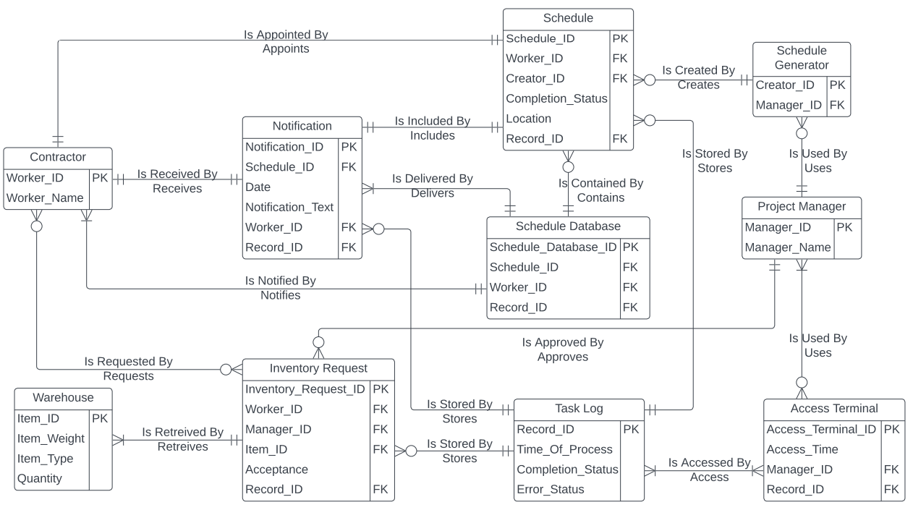

**1.01 Assumptions:**

1. It shall be assumed that ‘Record Database’ logs ‘Schedule’, ‘Inventory Request’, ‘Record Access Instance’ and ‘Notifications’ completion status, error status, and time of process.
2. It shall be assumed that ‘Project Manager’ uses a ‘Schedule Generator’ and uses a Creator ID unqiuely affixed with his Manager_ID.
3. It shall be assumed that ‘Schedule Database’ is capable of sending out schedule notifications to a specific ‘Contractor” on a daily basis.
4. It shall be assumed that each ‘Notification’ includes one ‘Schedule’ and is sent its respective ‘Contractor’.
5. It shall be assumed that ‘Contractor’ and ‘Project Manager’ shall communicate outside of this system design.
6. It shall be assumed that each ‘Inventory Request’ could contain more than one Item_ID
7. It shall be assumed that ‘Project Manager’ uses a ‘Record Access Instance’ terminal that accesses ‘Schedule’ based on an inputted Record_ID.
8. It shall be assumed that ‘Project Manager’ uses a ‘Record Access Instance’ terminal that accesses ‘Record Database’ based off a inputted Record_ID and in doing so the ‘Record Database’ logs the access.
9. It shall be assumed that ‘Inventory Request’ requires the acceptance of the ‘Project Manager’ for the request of the ‘Contractor’ before it retrieves the Item_ID.

*"It shall be assumed some of the data dictionary's attributes are unnecessary or wording aren't updated yet."*

**1.1 Alternative Matrix:**

The decision whether to use a custom made, packaged software, or build off a package software and have an employee maintain it were accessed based on AD&C Management’s functional requirements.

| **Evaluation Criteria** | | **Relative Importance** | **Alternative 1: *Contractor Make It Based Of*** | **Score** | **Weighted** | **Alternative 2: *Current Employee*** | **Score** | **Weighted** | **Alternative 3:** | **Score** | **Weighted** |
| --- | --- | --- | --- | --- | --- | --- | --- | --- | --- | --- | --- |
| **(Weight)** | ***Pre-Package Software. Employee Maintains.*** | **(1-5)** | **Score** | ***Use Prepackaged Software*** | **(1-5)** | **Score** | ***Custom Made (Inhouse)*** | **(1-5)** | **Score** |
|  | Reliability | 15 | Very Reliable | 5 | 75 | Limited Reliability | 3 | 45 | Not Reliable | 1 | 15 |
| Database Capabilities | 10 | Very Flexible | 5 | 50 | Limited Capabilities | 3 | 30 | Not Flexible | 1 | 10 |
| Integration With Existing Infrastructure | 10 | Very Consistent With Needs | 5 | 50 | Limited Compatibilities | 4 | 40 | No Consistency | 1 | 10 |
| Maintainability | 15 | On Demand Maintainability | 5 | 75 | Limited Maintainability | 3 | 45 | No Maintenance | 1 | 15 |
|  | Cost | 15 | Cost Heavy | 1 | 15 | Adequate Cost | 3 | 45 | Cost Heavy | 1 | 15 |
|  | Time Saving | 10 | Time Consuming | 2 | 20 | Saves Time | 5 | 50 | Time Consuming | 2 | 20 |
| Skill Requirement | 20 | Minimum Skill Required | 3 | 60 | No Skill Required | 5 | 100 | Skill Heavy | 1 | 20 |
| Long Term Benefits | 10 | Really Beneficial | 5 | 50 | Depreciating Benefits | 2 | 20 | No Benefits | 1 | 10 |
|  | Total | 105 |  |  | 395 |  |  | 205 |  |  | 115 |

Based upon an analysis of AD&C Management’s strength and weakness, we decided the most appropriate system design implementation shall be one where the contractor makes the system based off of pre-package software designs.

**1.2 Second Alternative Matrix:**

The decision whether to use a server-based, thin client server, or a thick client-server was made based on AD&C Management’s nonfunctional requirements.

| **Requirements** | | **Server-** | **Thin Client-** | **Thick Client-** |
| --- | --- | --- | --- | --- |
| **Based** | **Server** | **Server** |
| Operational Requirements | | | | |
| Run on Apple and Android | |  | X |  |
| Compatible with any Web Browser | |  | X |  |
| Maintainability | | X | X |  |
| Performance Requirements | | | | |
| Update Changes within 5 Minutes | |  | X |  |
| Availability/Reliability | | X | X |  |
| Security Requirements | | | | |
| Access Control | | X |  |  |
| Encryption/ Authentication | |  | X |  |
| Virus Control | | X |  |  |
| Stores Data in Cloud | |  | X |  |
| Cultural/Political Requirements | | | | |
| Spanish Mode Available | |  | X |  |
| Differentiate Language | |  | X |  |

**1.2.1 System Architecture Decision:**

We are building a communication structure for AD&C Management. Portability and availability are crucial since construction work isn't a fixed project in any location. Thick Client-Servers would be especially hard to implement due to their inability to connect contractors with the necessary information on demand. Thin Client-Server's accessibility and ability to provide information in Spanish would improve operations. Although Server-Based architecture tends to control access and virus better, Thin Client-Servers are more encrypted and have safer data storage systems.

**1.3 Hardware and Software Specification:**

We shall utilize Thin Client - Servers. The Thin Client Server’s design operation system, special software, hardware, and network client and servers based of AD&C Management’s functional and nonfunctional requirements are evaluated.

|  | **Standard Client** | **Standard Web Server** | **Standard Application Server** | | | **Standard Database Server** | | |
| --- | --- | --- | --- | --- | --- | --- | --- | --- |
| **Operation System** | Window 10 Pro | Linux | Linux | | | Linux | | |
| **Special Software** | Apple Ipad 10th Gen | Apache | Java | | | Oracle | | |
| **Hardware** | 1 TB Intel Core i5 8400 six core | 8 TB Disk Drive Xeon | 8 TB Disk Drive Xeon | | | 32 TB Disk Drive Raid | | |
| processor 22 inch LED Monitor | E5- 4600 v4 | E5- 4600 v4 | | | Xeon 28 Core Processor | | |
| **Network** | Always On Broadband | Dual 100 Mbps Ethernet | Dual 100 Mbps Ethernet | | | Dual 100 Mbps Ethernet | | |